Practice Lab 11

CORRELATED SUB QUERY

Question-01: Write a query that displays every album title with total count of its tracks in descending order. [347 Rows]
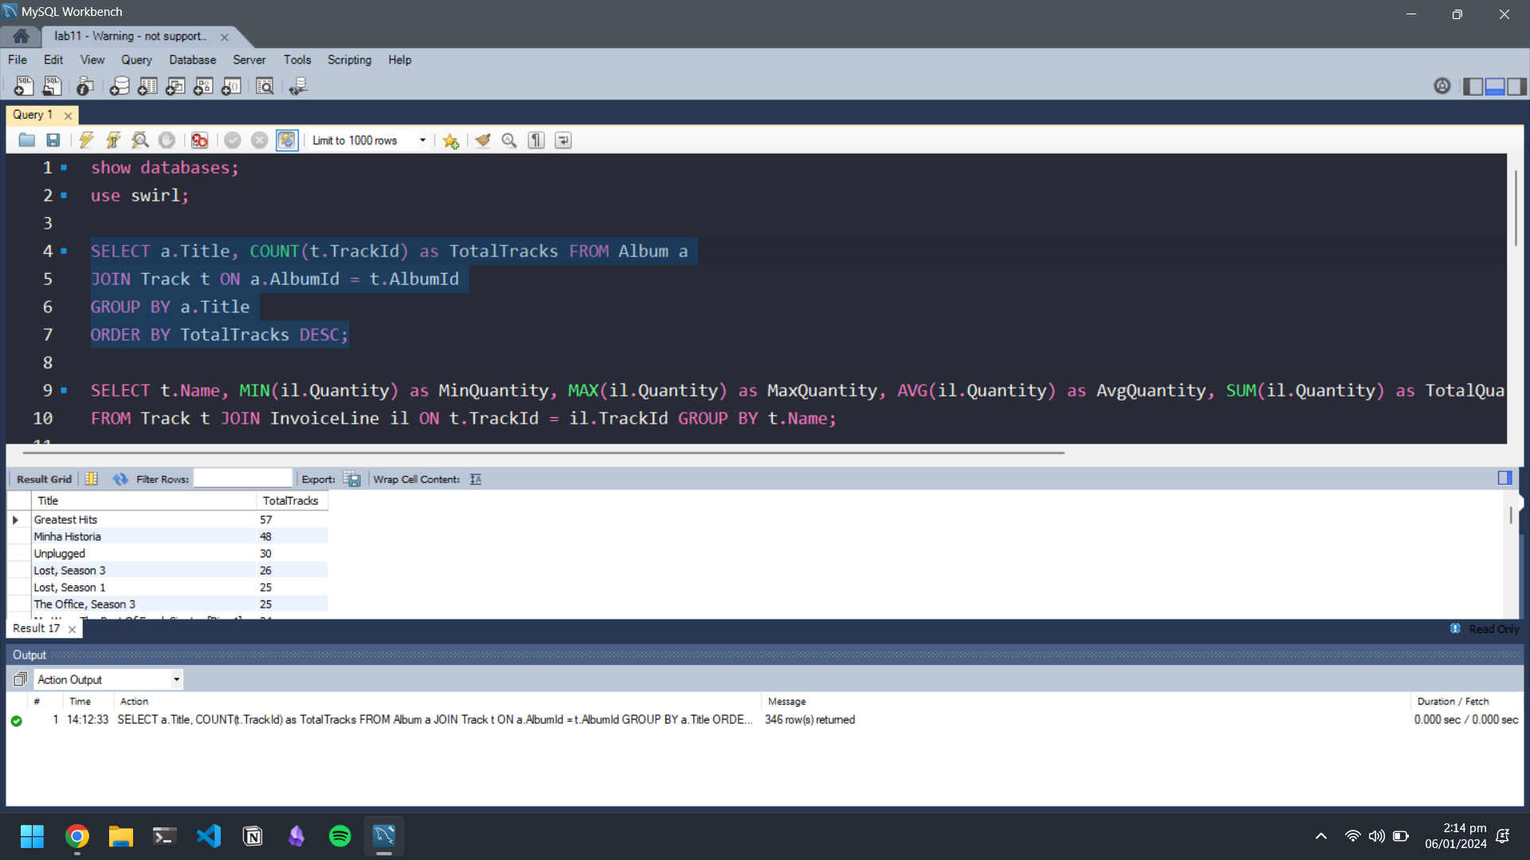

Question-02: Write a query that display name of every track with min, max, average and total quantity ordered for all tracks.
[1000 Rows]
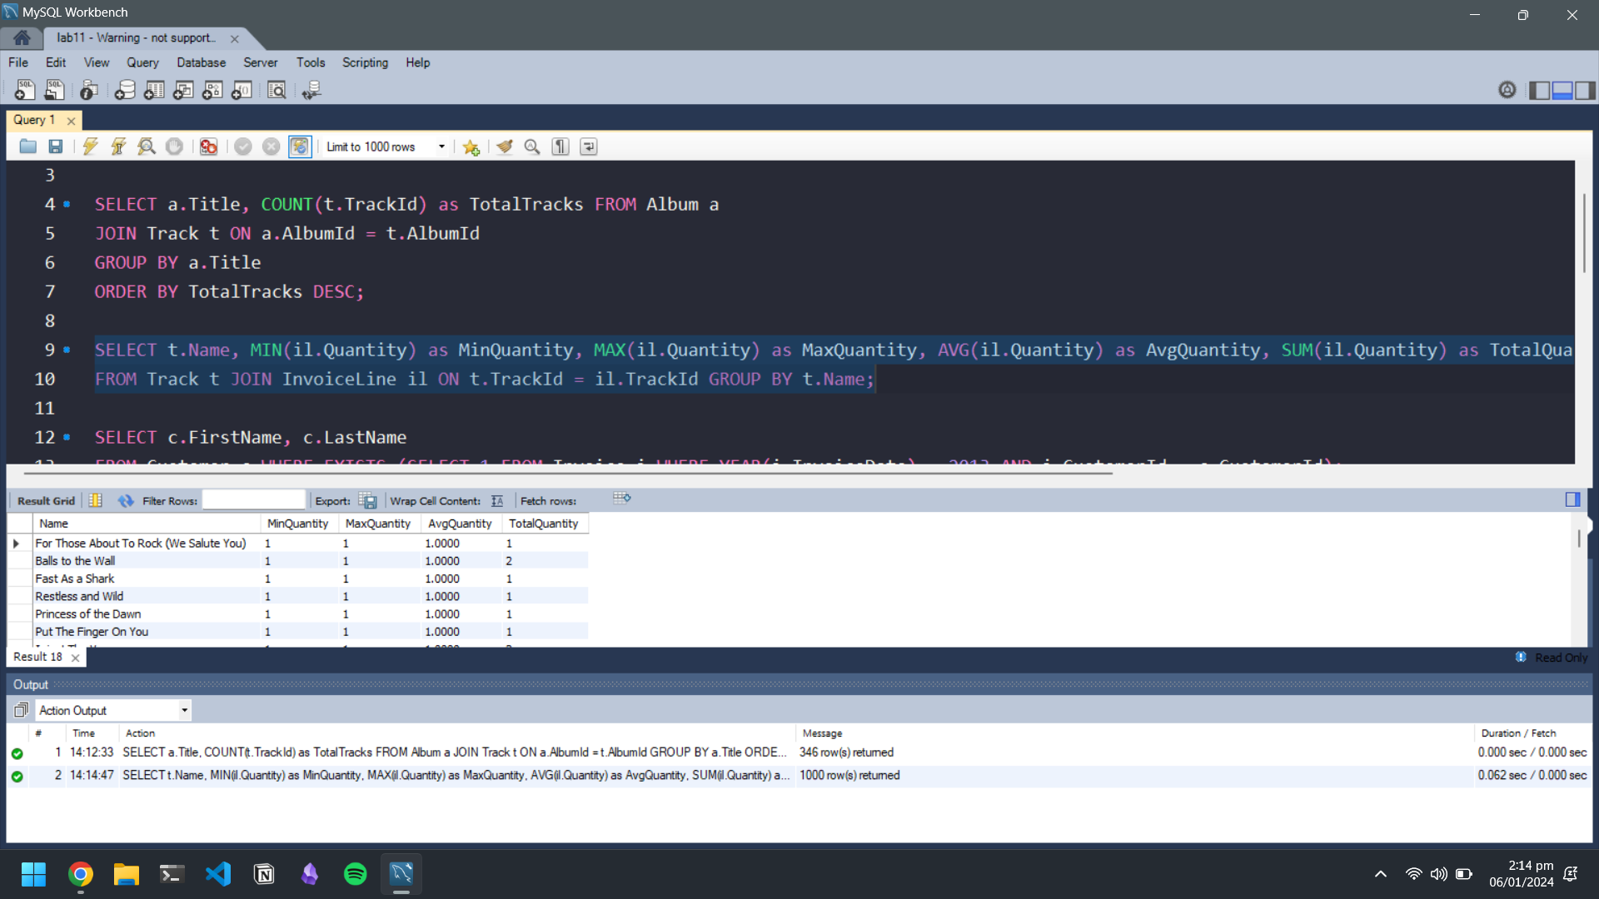

Question-03: Write a query that display name of all those customers whose invoice date is in year 2013. (Use EXISTS operator)
[46 rows]
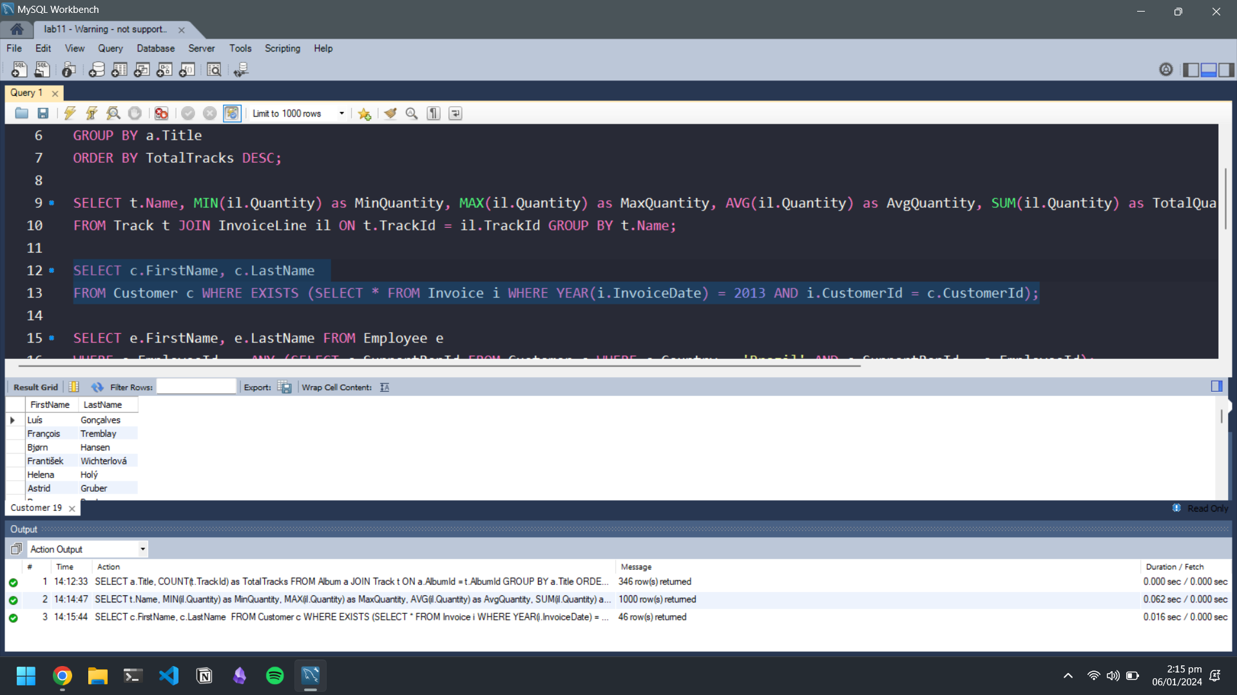
Question-04: Write a query that display name of those employees whose at least one customer lives in ‘brazil’ (Use ANY Operator)
[3 Rows]
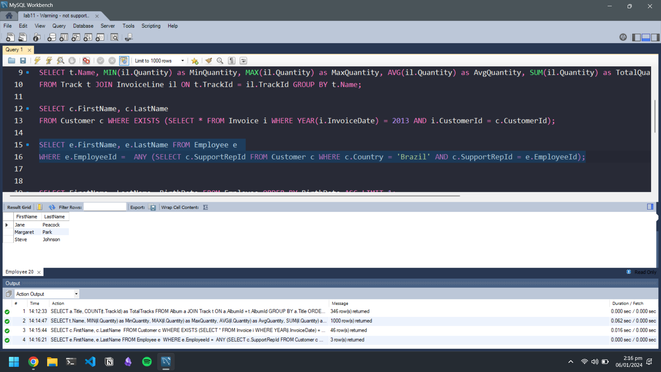
Question-05: Dipslay firstname, lastname and birthdate of employee who born first. [1 Row]
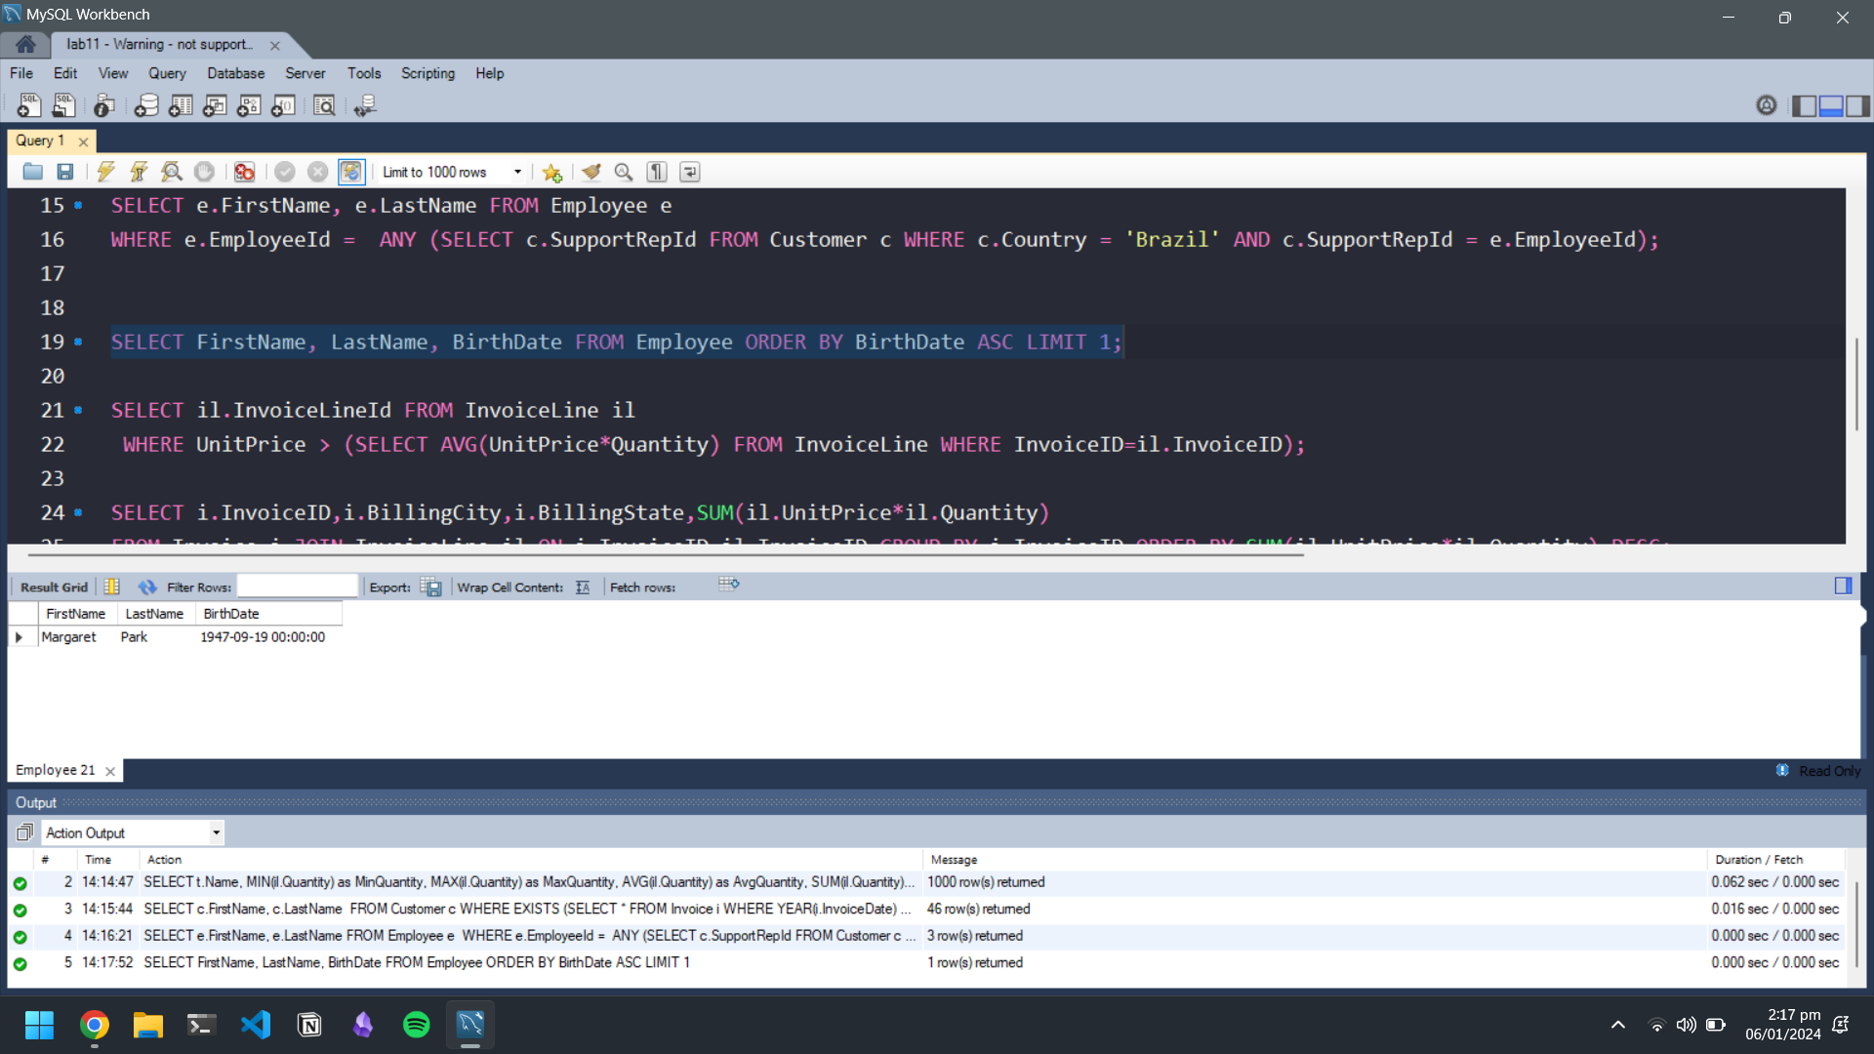

Question-06: Write a correlated subquery to Display InvoiceLine Id whose Unitprices are greater than the average Unit price of all Invoices in each InvoiceLine. [111 Rows]
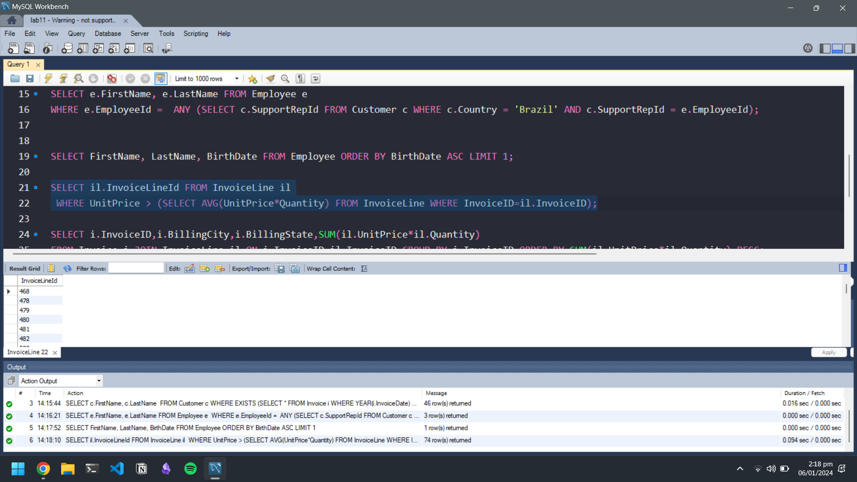
Question-07: Write a correlated to display Invoice Id, Billing city billing state and total sales in descending order. [412 Rows]
Hint: One Sale= unitprice* quantity
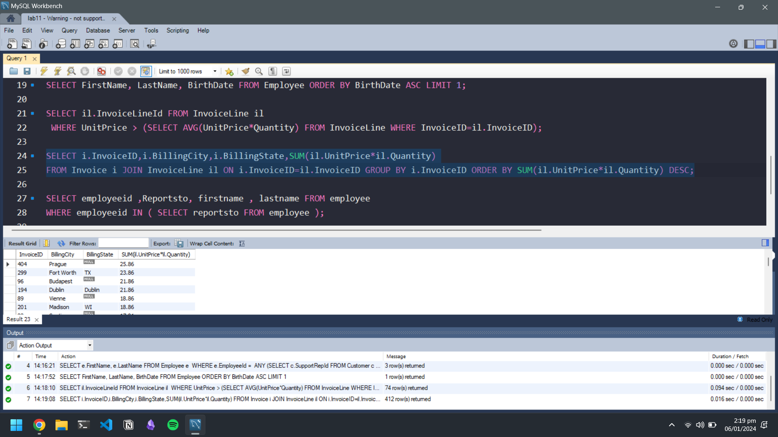
Question-08: Write a query to display the employee_id, manager_id, first_name and last_name of those employees who manage other employees. [3 Rows]
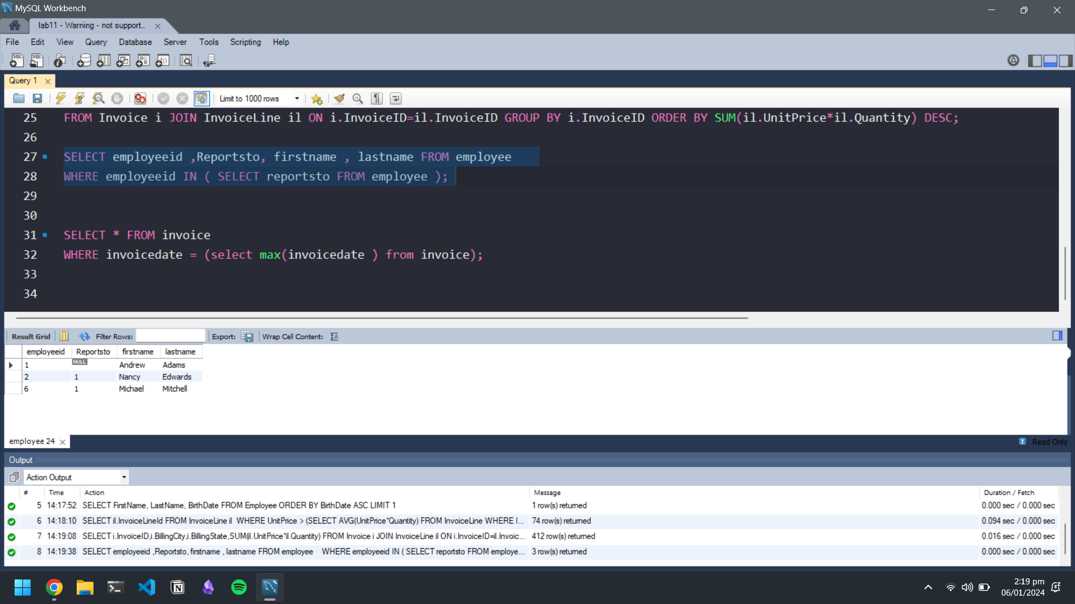
Question-09: Write a correlated subquery display invoice information having latest date. [1 Row]

